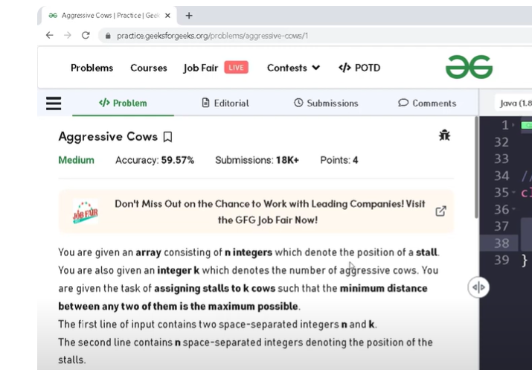
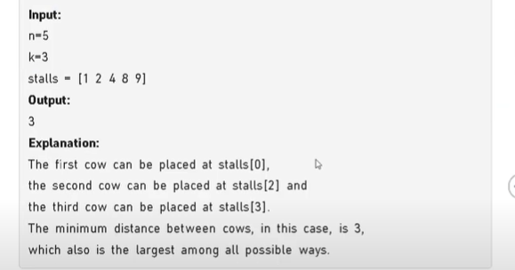

🔸 Problem: Aggressive Cows
We are given:
- stalls = {1, 2, 3, 6, 7} → positions of stalls
- cows = 3 → number of cows to place
We need to place the cows in stalls such that the minimum distance between any two cows is as large as possible.
This is a classic binary search on answer problem.

🔸 Step 1: Sort the stall positions
Already done in code:
stalls = {1, 2, 3, 6, 7} (already sorted)

🔸 Step 2: Binary Search on Distance
We’ll try to maximize the minimum distance between cows.
- start = 1 (minimum possible distance)
- end = 7 - 1 = 6 (maximum possible distance)
We perform binary search between 1 and 6 to find the best possible answer.
